Defect Component Print
Use Case

修订历史
章节号 | 章节名称 | 变更原因 | 变更内容描述 | 变更日期 | 版本
All | All | 新建 | 初版 | 2014-12-16 | 0.01a
2.2.5 | 業務規則 | 修改 | Save時需一併更新DefectComponent | 2015-01-22 | 0.01a

目录
1. 前言 4
1.1. Introduce 4
1.2. References 4
2. Defect Component Print 4
2.1. UI說明 4
2.2. UC說明 5
2.2.1. 功能及目标 5
2.2.2. 前置条件 5
2.2.3. 后置条件 5
2.2.4. 过程描述 5
2.2.5. 业务规则 6
3. Defect Component Reprint 9
3.1. UI說明 9
3.2. UC說明 10
3.2.1. 功能及目标 10
3.2.2. 前置条件 10
3.2.3. 后置条件 10
3.2.4. 过程描述 10
4.1.1. 业务规则 11
Appendix 12
Question 12

前言

Introduce
本文档用于定义[Defect Component Print]部分的业务需求，作为规格设计与程序设计的依据；读者为iMES 2011项目的用户，设计人员，开发人员和质检人员。

References

Defect Component Print

UI說明
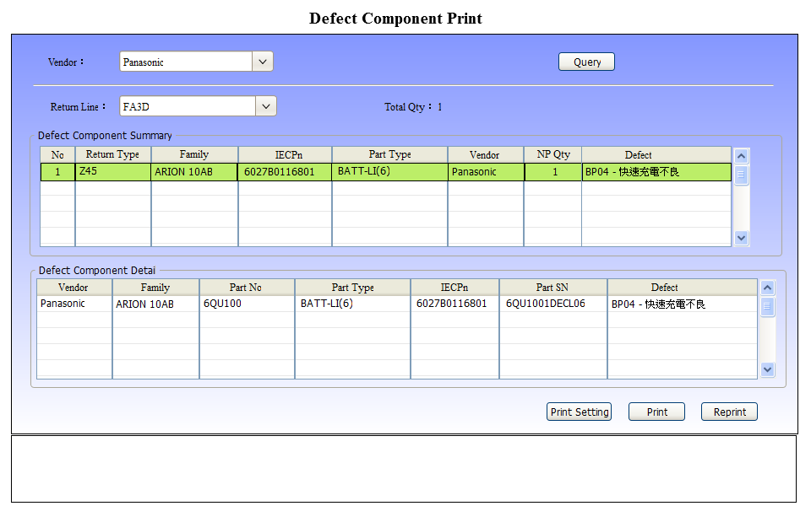

UC說明

功能及目标
本站实现的功能：
- 生管助理打印退料單

進入途徑：在iMES框架FA Function Tree的Defect Component节点下点击“Defect Component Print”节点后进入。

前置条件
Defect Component Rejudge

后置条件
IQC系統登錄

过程描述
UI | System
 | 1.Get [Vendor] and Display
 | 2.Get [Return Line] and Display
3.用戶按下[Query]按鈕
 | 4.根據 [Vendor]查詢尚未打印的退料彙總資訊
 | 5.顯示退料彙總資訊於Grid[Defect Component Summary]。
6.用戶於Grid[Defect Component Summary]點選任一筆紀錄
 | 7.根據點選紀錄的Family、IECPn、Vendor、DefectCode查詢退料明細資訊，並顯示於Grid[Defect Component Detail]。
8. 用戶按下[Print]按鈕
9.Check Input
- 若 [Return Line]為空值，則報錯：”請選擇 Return Line !”
 | 10.Save
 | 11.Print
 | 12. 於下方訊息框顯示：SUCCESS! [BatchID：@BatchID]
13. 用戶按下[Reprint]按鈕
14.以另開視窗顯示[Reprint]頁面，
請參閱[3.Defect Component Reprint]

业务规则
Function | Rule
1.Get [Vendor] and Display | - 至DefectComponent表查詢Vendor資訊  select distinct Vendor  from DefectComponent  - 預設：第一個選項。
2.Get [Return Line] and Display | - 至ConstValueType表獲取Type=’SAPReturnLine’的值  - 預設：空值
4. 根據 [Vendor]查詢退料彙總資訊 | 獲取頁面選擇的[Vendor]為@Vendor  至DefectComponent表查詢 Vendor = @Vendor，且狀態為’11’ (覆判為不良品)、且BatchID為空值的資訊  - 查詢資料總筆數  select COUNT(*) as Total  from DefectComponent  Where [Status] = '11' and isnull(BatchID, '') = ''  2. 查詢彙總資訊  select 'Z45' as ReturnType ,Family, IECPn, PartType, Vendor,  COUNT(PartSn) as NPQty, DefectCode, DefectDescr  from DefectComponent  Where [Status] = '11' and isnull(BatchID, '') = ''  group by Family, IECPn, PartType, Vendor, DefectCode, DefectDescr  order by Family, IECPn, Vendor, DefectCode
5. 顯示退料彙總資訊於Grid[Defect Component Summary]。 | 總數資料  Total Qty = 資料總筆數  Grid[Defect Component Summary]  - No：流水號，起始號碼1，每列累加1。  - Defect 顯示 DefectCode + ‘-’ + DefectDescr
7.根據點選紀錄的Family、IECPn、Vendor、DefectCode查詢退料明細資訊 | 獲取點選紀錄的Family為@Family  獲取點選紀錄的IECPn為@IECPn  獲取點選紀錄的Vendor為@Vendor  獲取點選紀錄的DefectCode為@DefectCode  至DefectComponent表查詢明細資料  select Vendor, Family, PartNo, PartType, IECPn, PartSn,  DefectCode, DefectDescr  from DefectComponent  Where [Status] = '11' and isnull(BatchID, '') = '' and  Family = @Family and IECPn = @IECPn and  Vendor = @Vendor and DefectCode = @DefectCode  order by Family, IECPn, Vendor, DefectCode
10.Save | 獲取頁面輸入的ReturnLine為@ReturnLine  獲取資料總筆數Total Qty為@TotalQty  獲取查詢結果任一筆的Vendor為@Vendor  - 產生BatchID為@BatchID  BatchID編碼規則(共11位)：  - Site(3位)：獲取SysSetting.Name=’Site’的值。(ICC/IPC)  - 客戶別(1位)：獲取SysSetting.Name=’CustomerCode’的值。(H (HP)、T (TSB)、W (WYSE))  - 日期年月(4位)：YYMM (YY：西元年後2位)。  - 流水碼(3位)：999 (001~999)  [註]調用Activity：GenSequenceNum  Property :  StoreSessionName="BatchID"  StoreInfoType=""  SpecType="SNRule"  SpecName="BatchID"  需新增ConValue設置  Type：’SNRule’  Name：’BatchID’  Value：SYS@Site~SYS@CustomerCode~Date@YYMM~Number@0123456789,001,999  - 新增/更新 BatchID至NumControl表：  以Site(3位) + 客戶別(1位) + 日期年月(4位) 組成@NoName，查詢是否存在NumControl表，  若不存在，則新增，@Value = @NoName+’001’；  若存在，取Value值後3位轉成數值再加1，並再轉成字串，前補0至總長度為3位。產生新的@Value=@NoName+新的字串值。  - NoType：’BatchID’  - NoName：Site(3位) + 客戶別(1位) + 日期年月(4位)  - Value：@Value  - Customer：SysSetting.Name=’Customer’的值  - 新增DefectComponentBatchStatus  - BatchID = 產生的BatchID  - Status = ‘00’ (已打印退料單)  - PrintDate = Current date (YYYY-MM-DD)  - Vendor = @Vendor  - ReturnLine = @ReturnLine  - TotalQty = @TotalQty  - Editor = Currenct User  - Cdt = Currenct Datetime  - Udt = Currenct Datetime  - 新增DefectComponentBatchStatusLog  - BatchID = 產生的BatchID  - Status = ‘00’ (已打印退料單)  - Editor = Currenct User  - Cdt = Currenct Datetime  - 整批更新DefectComponent  以退料明細資料的DefectComponent.ID為條件，更新DefectComponentLog  - ReturnLine = @ReturnLine  - BatchID = @BatchID  - Editor = Currenct User  - Udt = Currenct Datetime  - 整批新增DefectComponentLog  以退料明細資料的DefectComponent.ID為條件，新增DefectComponentLog  - ActionName = ‘DefectComponentPrint’  - ComponentID = DefectComponent.ID  - RepairID = DefectComponent.RepairID  - PartSn = DefectComponent.PartSn  - Customer = DefectComponent.Customer  - Model = DefectComponent.Model  - Family = DefectComponent.Family  - DefectCode = DefectComponent.DefectCode  - DefectDescr = DefectComponent.DefectDescr  - ReturnLine = @ReturnLine  - Remark = DefectComponent.Remark  - BatchID = @BatchID  - Comment = ‘’  - Status = DefectComponent.Status  - Editor = Currenct User  - Cdt = Currenct Datetime
11.Print | 1.根據[Maintain]子系統的LabelSetting配置，篩選需列印的Label。  [註]Activity：FilterLabelTypeRule  2.各Label Template的設定規則請參閱  \TSBIMES\Project\3.Code\Label\CQ TSB iMES Label.xlsx  3.Save：  Insert PrintLog  - Name = @LabelType  - BegNo = @BatchID  - EndNo = @BatchID  - Descr = ‘BatchID’  - Editor = Current User  - Cdt = Current Datetime  - LabelTemplate = @TemplateName  - Station = Current Station  4.執行列印(傳入參數 @BatchID)

Defect Component Reprint

UI說明
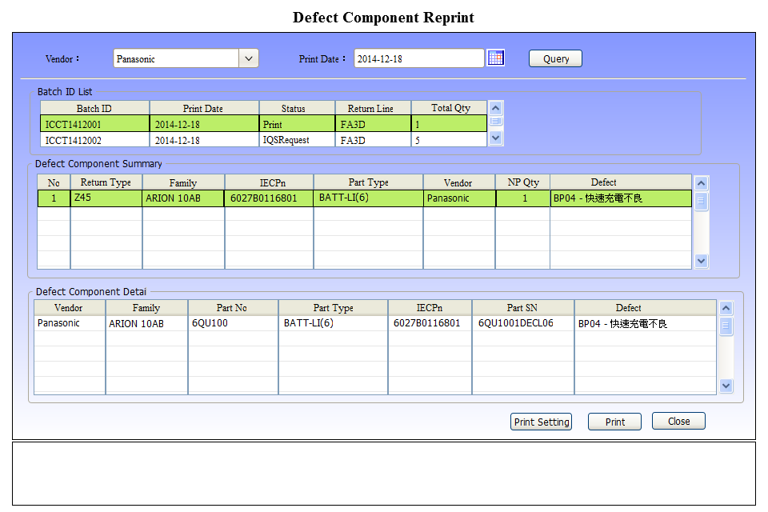

UC說明

功能及目标
本站实现的功能：
- 生管助理重印退料單

前置条件
已產生BatchID

后置条件
IQC系統登錄

过程描述
UI | System
 | 1.Get [Vendor] and Display
 | 2.Get [Print Date] and Display
3.用戶按下[Query]按鈕
- 根據 [Vendor]、[Print Date]查詢已打印的Batch ID清單，並顯示於Grid[Batch ID List]中
- 若[Print Date]為空值，根據[Vendor]查詢尚未打印的退料彙總資訊。
- 若[Print Date]為有值，根據[Vendor]、[Print Date]查詢已打印的退料彙總資訊
5. 用戶於Grid[Batch ID List]點選任一筆紀錄
 | 6. 根據 [Batch ID]查詢已打印退料彙總資訊，並顯示於Grid[Defect Component Summary]。
7.用戶於Grid[Defect Component Summary]點選任一筆紀錄
 | 8.根據點選紀錄的Family、IECPn、Vendor、DefectCode查詢退料明細資訊，並顯示於Grid[Defect Component Detail]。
9. 用戶按下[Print]按鈕
 | 10.Save
 | 11.Print
 | 12. 於下方訊息框顯示：SUCCESS! [BatchID：@BatchID]

业务规则
Function | Rule
1.Get [Vendor] and Display | - 至DefectComponent表查詢Vendor資訊  select distinct Vendor  from DefectComponent  - 預設：第一個選項。
2.Get [Print Date] and Display | 預設：系統日
4.根據 [Vendor]、[Print Date]查詢已打印的Batch ID清單 | 獲取頁面選擇的Vendor為@Vendor  獲取頁面選擇的Print Date為@PrintDate  至DefectComponentBatchStatus查詢Vendor = @Vendor，PrintDate = @PrintDate，且狀態不為’Finish’(退料完成)的退料資訊。  select a.BatchID, a.PrintDate, a.[Status], b.Value as Descr , a.ReturnLine, a.TotalQty  from DefectComponentBatchStatus a  inner join ConstValue b on b.[Type] = 'DCBatchStatus' and a.[Status] = b.Name  where a.Vendor = @Vendor and a.PrintDate = @PrintDate and  a.[Status] <> '30'
6. 根據 [Batch ID]查詢已打印退料彙總資訊 | 獲取點選的BatchID為@BatchID  至DefectComponent表查詢 BatchID = @BatchID的資訊  select 'Z45' as ReturnType , Family, IECPn, PartType, Vendor,  COUNT(PartSn) as NPQty, DefectCode, DefectDescr  from DefectComponent  where BatchID = @BatchID  group by Family, IECPn, PartType, Vendor, DefectCode, DefectDescr  order by Family, IECPn, Vendor, DefectCode
8.根據點選紀錄的Family、IECPn、Vendor、DefectCode查詢退料明細資訊 | 獲取點選的BatchID為@BatchID  獲取點選紀錄的Family為@Family  獲取點選紀錄的IECPn為@IECPn  獲取點選紀錄的Vendor為@Vendor  獲取點選紀錄的DefectCode為@DefectCode  至DefectComponent表查詢明細資料  select Vendor, Family, PartNo, PartType, IECPn, PartSn,  DefectCode, DefectDescr  from DefectComponent  where BatchID = @BatchID and  Family = @Family and IECPn = @IECPn and  Vendor = @Vendor and DefectCode = @DefectCode  order by Family, IECPn, Vendor, DefectCode
10.Save | 1.紀錄ReprintLog  Insert ReprintLog  - LabelName = @LabelType  - BegNo = @BatchID  - EndNo = @BatchID  - Descr = @LabelTemplate  - Reason = ‘’  - Editor = Current User  - Cdt = Current Datetime
10.Print | 1.根據[Maintain]子系統的LabelSetting配置，篩選需列印的Label。  [註]Activity：FilterLabelTypeRule  2.各Label Template的設定規則請參閱  \TSBIMES\Project\3.Code\Label\CQ TSB iMES Label.xlsx  3.執行列印(傳入參數 @BatchID)

Appendix

Question

